NAAN MUDHALVAN ARTS INTERNSHIP PROGRAM 2026
Frontend Web Development using React
Project Submission

STUDENT NAME : MANIKANDAN.S
YEAR : 3RD YEAR
COLLEGE CODE : BRUAU
COLLEGE NAME : GOVERNMENT ARTS AND SCIENCE COLLEGE AVINASHI (CO-EDUCATION)
DEPARTMENT : B.Sc (COMPUTER SCIENCE)
SEMESTER : IV SEMESTER
ROLL NO : 2422k1176
NMID : B8B4A6A24835349AC2C4C92F4603913
DATE : 18/06/2026
TITLE: MINI E-COMMERCE CART SYSTEM
GITHUB LINK : https://github.com/manikandans959754-wq

- ABSTRACT
This project features the development of SmartCart, a modern, high-performance, single-page E-commerce application built using React.js. The application provides a seamless and highly responsive user interface where customers can explore, search, and filter through a curated catalog of 30 premium products across multiple categories like Electronics, Home, Fashion, and Beauty. Equipped with an interactive dynamic sidebar shopping cart, the application tracks items, manages quantities, and updates total pricing in real-time, delivering a premium and frictionless shopping experience.

- PROBLEM STATEMENT

Traditional E-commerce web applications often suffer from slow performance due to frequent page reloads and heavy server overhead during simple user actions like filtering products or updating a shopping cart. This sluggish behavior disrupts the user experience and can lead to cart abandonment. There is a clear need for a lightweight, client-side solution that handles product catalog navigation, real-time searching, and shopping cart operations instantaneously without refreshing the browser window.

3.OBJECTIVES

- ​To design and implement a fast, responsive Single Page Application (SPA) using React.js functional components.
- ​To create an optimized, real-time search and categorization system that lets users filter 30 verified items instantaneously.
- ​To develop a robust client-side state management flow for an interactive slider cart (Shopping Bag) that allows users to add, remove, and adjust item quantities dynamically.
- ​To accurately compute product totals and multi-item pricing metrics instantly on the client side.

4.PROJECT SCOPE

- In-Scope Features: A responsive product grid view featuring 30 HD products, instant category tab switching, search input matching, a sliding overlay cart panel, increment/decrement controls for quantities, individual item removal, and a simulated seamless checkout procedure.
- ​Out-of-Scope / Future Enhancements: Persistent storage (Database), backend user registration and authentication, real-time inventory management, and integration with an actual payment gateway processing framework.

5. TECHNOLOGIES USED

- Frontend Framework: React.js (Functional Components, Hooks)
- ​Styling Framework: Inline CSS utilizing JavaScript style objects (Inter Typography, clean modern UI cards, responsive layouts)
- ​Icon Library: Lucide React (ShoppingBag, Search, Trash2, Plus, Minus, X, Star, Zap, ChevronRight)
- ​Development Environment: Node.js, npm package manager

6. APPLICATION FLOW

- Landing & Initialization: When the user launches the application, the system renders a clean header bar with a global search input and a reactive cart status badge alongside a 30-item product dashboard.
- ​Catalog Filtering: The user clicks on any category tab (All, Electronics, Home, etc.) or types in the search bar. The application captures this interaction and instantly reduces the product grid to show only matching elements without lagging.
- ​Cart Assembly: The user selects "Add to Bag" on a product card. The app instantly initializes or increments that specific item in the state array and bumps up the navbar's shopping bag counter.

7. KEY REACT CONCEPTS USED

- useState Hook: Used to track reactive application components that shift with user behavior, such as the active shopping cart contents (cart), current text input queries (search), selected category filter (activeCat), and the sidebar's open state toggle (isBagOpen).
- ​useMemo Hook: Implemented to wrap the array filter execution (filtered). This optimizes application performance by caching the computed result list and preventing expensive recalculations unless the product dependencies change.
- ​Conditional Rendering: Utilized javascript ternary syntax to swap out layout UI structures dynamically (e.g., rendering an empty cart message when the bag array length is zero versus rendering the list layout when active items exist).
- ​Lists and Keys: Executed JavaScript .map() methods to smoothly map data structures directly into visual DOM nodes, utilizing unique database identifiers (key={p.id}) to help React efficiently identify changing items.

8. CHALLENGES FACED

- Challenge - Duplication in Array Mutations: Initially, clicking "Add to Bag" multiple times on the same item appended duplicate rows inside the shopping bag grid instead of merging them and smoothly stepping up the unit counter.
- ​Resolution - State Validation Logic: Resolved by implementing an array search check via .find() inside the state update wrapper function. If the product ID is already in the cart, the system maps across the active array and selectively updates only the matching object's nested quantitative field (qty: i.qty + 1), preserving rendering order.

9. EXPECTED OUTPUT

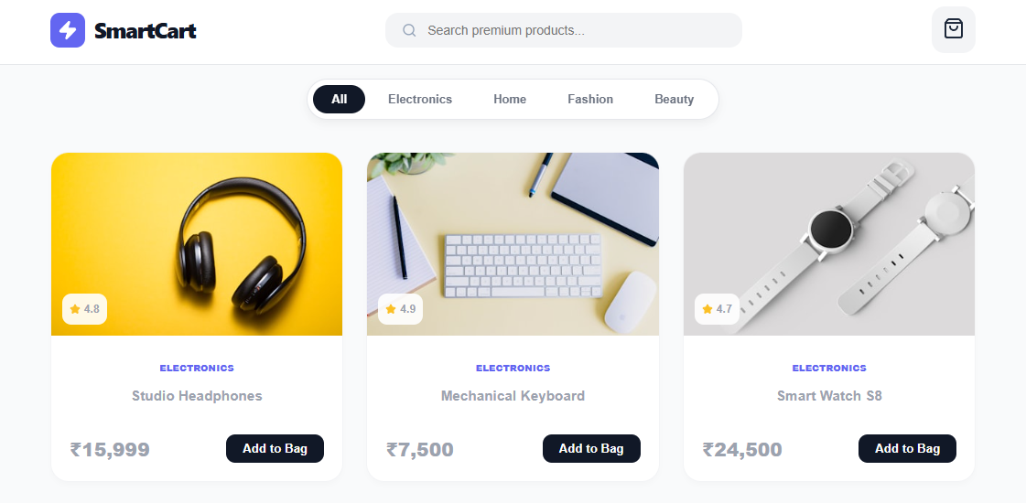

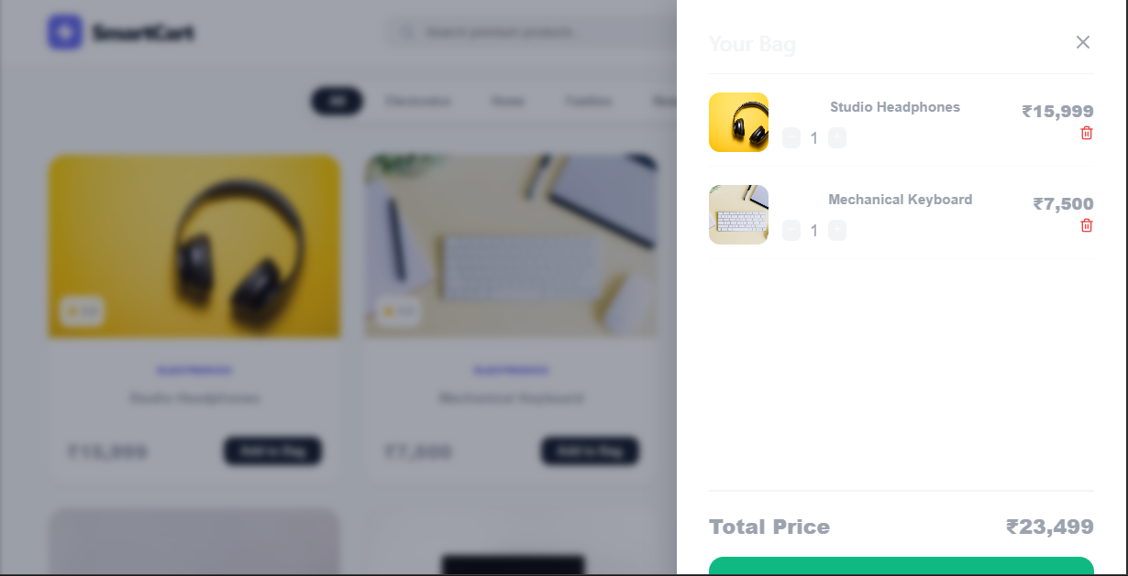

10. LEARNING OUTCOMES

- Mastered React state architecture rules, including passing and modifying values safely using functional updates and optimizing component lifecycles.
- ​Gained experience working with array management methods (.filter(), .map(), .reduce()) to handle UI state.
- ​Acquired practical frontend engineering skills to construct fully responsive, high-end layouts directly from raw code strings using modern tooling.

11. CONCLUSION

The execution of the SmartCart application successfully showcases the practical power of React.js in deploying lightning-fast, user-centric e-commerce systems. By shifting complex operations directly onto the client side via custom hooks and reactive state rules, the app eliminates common performance issues like slow loading times. This project was an excellent opportunity to apply the core web development principles taught during the Naan Mudhalvan internship program.

